Teardown report
-Solomon Levi
PROV/ASQR/BTECH/07/26/001
Introduction
On 15th September, 2026 as a part of the Innovation and Invention Studio (course code : E4QAA 26208), students were grouped into different teams to address different tasks. The objective of the day was to examine the assigned household appliance and dismantle the device to deepen the understanding of the integrated system of different components.
Team and Product Specifications
I was assigned to a group with the following classmates : Ravi(ASQR029), Vignesh(ASQR015), Vaibhav(ASQR028), Yuva(ASQR026), Gokul (ASQR016), Muhammed(ASQR019). The consumer appliance assigned to us was a Electric Kettle.

Product specifications:

Model Name : Greenchef Swift Electric Kettle
Capacity :1.5 Liters
Material :Stainless Steel
Colour :Steel
Voltage :220
Dimensions :20L x 16W x 20H Centimeters
Wattage :1500 Watt Hours

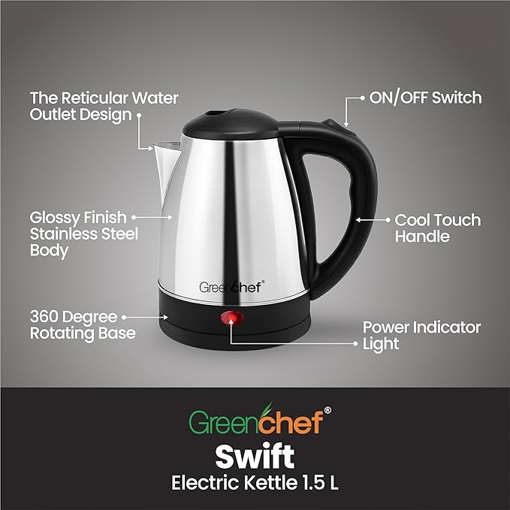
Components Analysis
Electrical : 360⁰ swivel base with concentric brass contacts, power cord, LED indicator.
Thermal : 1500W under-plate stainless steel heating element, stainless steel body
Control : Primary steam bimetallic strip(switch) , dry-boil protection bimetallic strip
The analog sub-systems in the electric kettle include the 360⁰ cordless power coupler subsystem, resistive heating system, switch system and the light indicator system. The kettle does not contain any sort of digital subsystems.

Functioning of each sub-system
360⁰ cordless power coupler subsystem :
The 360° cordless power coupler is the primary electrical power interface of the kettle. It comprises of a base(with 2 golden circular pin) and the socket(situated at the bottom of the kettle). It allows 220 AC mains power to transfer safely from the plugged-in station base into the kettle without any fixed wire connections. This cordless setup aids the consumers to live life with ease and efficiency. The user can easily place the jug, rotate or lift the jug without touching any exposed conducting elements of the whole electric kettle setup due to this cordless technology.
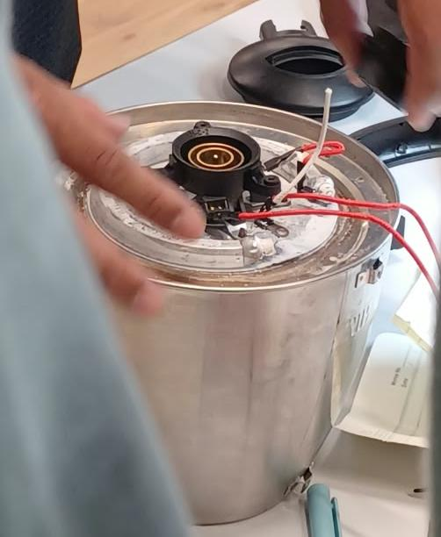
Resistive heating system :
The resistive heating subsystem is the main energy transformation component in the kettle. Its sole purpose is to convert incoming 220 AC electrical energy directly into heat energy to boil water. The subsystem works on the principle of Joule Heating. As high AC current flows through this resistive wire(the circular coil under the jug), electrical energy is converted to heat at a rate determined by its power rating (1350 Watt as stamped on the base plate).
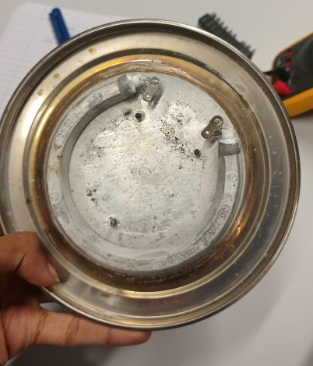
Switch system :
The switch system acts a control point and is an essential safety precaution. In side the switch there is a bimetallic steam disc. When temperature increases to 100⁰C, one side of the disc expands that snaps the switch OFF. This showcases automation as the system doesn’t require the consumer to be physically present to turn the kettle off manually.
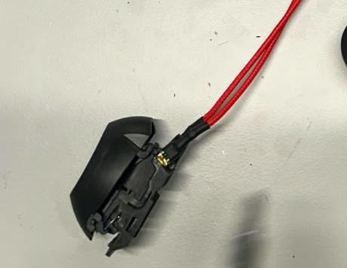
Light indicator system :
The indicator system serves as a visual confirmation whether the current is passing through the jug through the cordless power system. It consists of a LED light source and a resistor for it. The system is connected in parallel to the 2 terminals of the resistive coil(heating element). Because it is wired in parallel, current only flows through the lamp when the primary steam switch and thermal cutouts are closed (ON position). The moment a bimetallic switch trips open, power to both the element and the lamp is cut simultaneously.
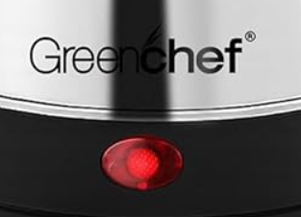
Flowchart
Jug placed on top of base
Water boils 100(1000

Working Run Through
- 220V AC: mains power supply from the wall socket.
- Power Cord: carries electricity from the outlet to the kettle.
- Base of the Kettle: holds the plug pins that send power upwards.
Action: the kettle jug is placed directly on top of this base.
- Socket of the Jug: metal contacts at the bottom of the jug touch the base to receive power.
- ON/OFF Switch: pressing the switch closes the circuit so electricity can flow.
- Parallel Power Split: power divides simultaneously into two components:
- Resistive heating in the coil: the heating element gets hot and warms the water.
- Light indicator (ON/OFF): turns on to visually confirm the kettle is actively heating.
- Water Boils: boiling creates hot steam inside the jug.
- Bimetallic disc in switch: steam heats the metal disc, causing it to snap and pop open.
- Power Cutoff: the snapping disc pushes the switch contacts open, stopping the current and turning off the kettle.

Conclusion
The teardown activity was quite an hands on experience that helps us understand that common physical principles, when used in the right combinations, could produce a reliable and featured product. Dismantling and analysing every major subsystem helped us understand how individual modules need to communicate and depend on each other. For example, if the LED was connected in series, then the high-resistance resistor would not allow enough current to heat the coil and even if we use a higher rated bulb in place of an LED, any fault in the bulb would instantly break circuit at that point.
This activity was exciting, educative and empowering to me. Through teamwork and individual reflection the functioning of an electric kettle has been deciphered and this marks a start to journey of an engineer. I look forward to continue participate and engage in these activities and I will commit to expanding my level of expertise over as many as domains as possible.

